“Title” screen with options to choose machine area and mode

Main window, built with options from title screen. Each magnet can be selected individually or in groups. Monitors magnets, grouped by type. Side Buttons also allow:

Code overview

“magnetAppController” controls everything. Owns all GUI classes and magnetController flavours.

Many GUI classes are built in QT designer, so have ‘Ui_***\*\*\*.ui***’ ‘***Ui_***.py***’ and ‘***GUI_***.py***’ versions. Bespoke ***GUI_magnetWidget*** made up of a collection of widgets are used to monitor each magnet and are embedded in the ***‘GUI_mainView’*** .Custom load and save windows allow the loading, previewing and saving of a DBURT. The option to load only quads, only corrects or all magnets is avialable.

**Class heirarchy**

**magnetAppController**

* interface between GUI classes and magnetController

**dburtLoadView (GUI)**

* preview dburt
* load dburt, for all magnets, quads only, corr only

**dburtSaveView (GUI)**

* save DBURT with comments keywords /

**magnetController**

* Flavour determined by **startView** choices
* Control / monitor selected magnetsArea

**mainView (GUI)**

* Monitor Mags (Mags determined by flavour of **magnetController**

**magnetWidget (GUI)**

* Bespoke widget to monitor / control magnet parameters
* 1 per magnet

**Main**

**magnetApp**

init QtGui.QWidget

**startView (GUI)**

* Chose machine mode and Area

**magnetObject** (Reference)

1 per magnet  for each magnet in the controller

Most GUI buttons are connected in the magnetAppController (some simple functions like select all in mainView are handled local to that class.

There is no threading, there are no complex procedures performed by this app all the function calls are to the magnetController (except some trivial GUI functions like button connecting).

GUI updating happens via a QT timer that calls update on each magnetWidget every 200ms. Each magnetWidget holds a magnetObject reference and when update is called the latest values are accessed and the magnetWidget updates itself.

GUI Panels

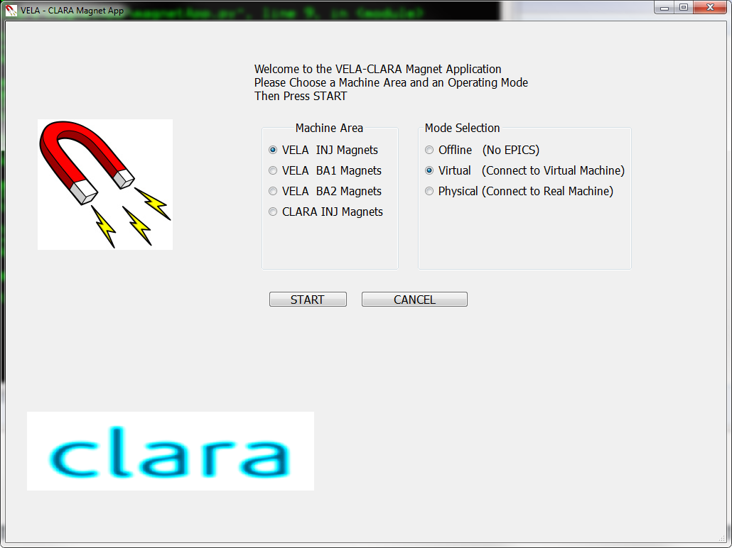

startView, radio buttons select Machine Mode and Area

From this correct magnetController is instantiated and main view built

mainView, monitor magnets (individual magnet widgets for each magnet). Main buttons perform basic operations on selected magnets. “All ... “buttons work whether magnet is selected or not

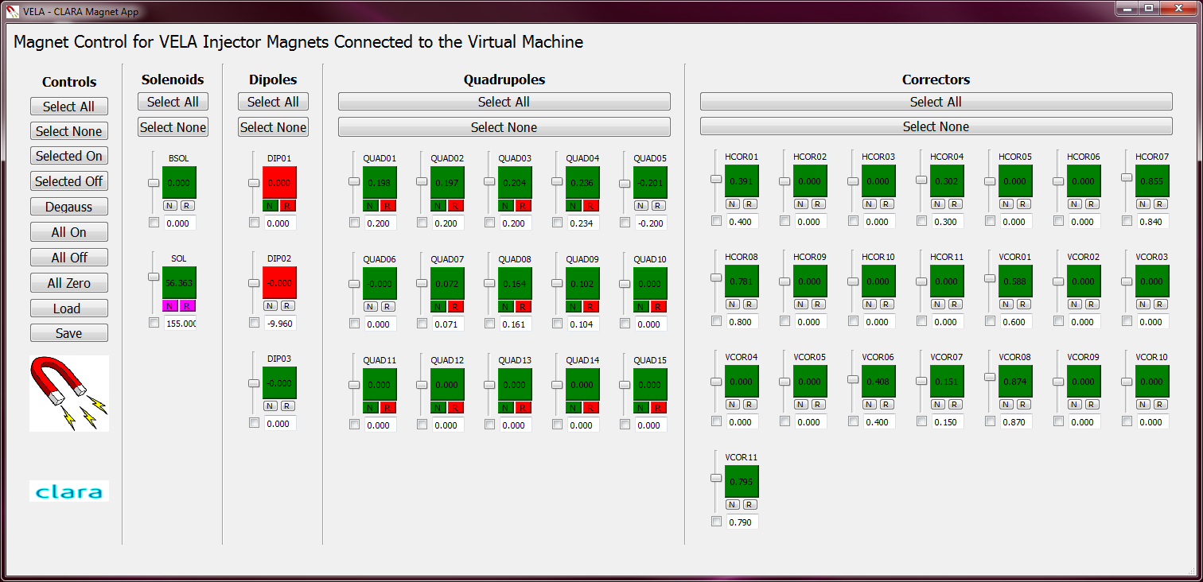

**dburtLoadView.** File selector, View, shows file (RHS example)

radio button to apply file to different magnets

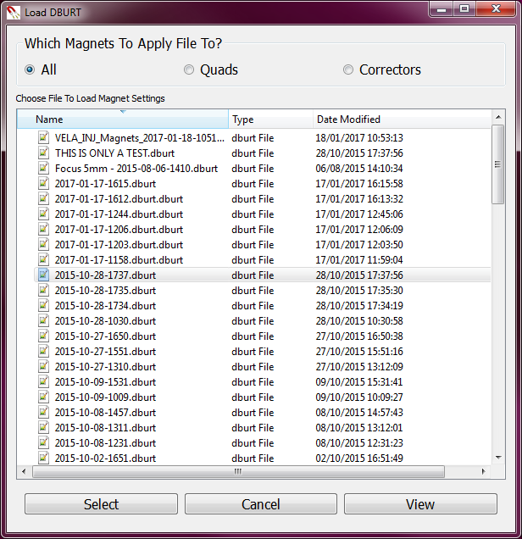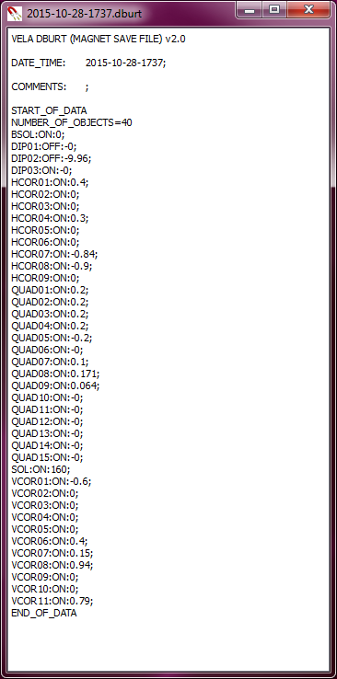

**dburtLoadView.** File selector, View, shows file (RHS example)

radio button to apply file to different magnets

